C0541 - CRM Changing Opportunity in IFS

|  |  |  |  |  |
| --- | --- | --- | --- | --- |
| **Ver** | **Date** | **Author** | **Comments** | **Reviewed by** |
| 1 | 01/03/2020 | Tom Bell | CRIM 0527 - CRM | TBC |
|  |  |  |  |  |

Requirements 2

Prerequisites 2

Solution Overview 2

Solution Details 2

Security 3

Companies 3

Data Migration 3

Test Steps 3

Technical Implementation 3

Requirements

A user must only be able to close a Business Opportunity with Closed Status: Won, if converting the Opportunity to an object in IFS such as a Sales Order or Service Quotation etc.

Prerequisites

<Describe any pre-requisites that this development may rely upon, data configuration or other developments>

Solution Overview

A user must only be able to close an Opportunity with Closed Status: Won, if converting the Opportunity to an object in IFS such as a Sales Order or Service Quotation etc.

**Development route options for this CRIM are as follows:**

* Remove Closed Status: Won option from drop down when closing an Opportunity, if closing the opportunity does not convert it to another object in IFS.
* Produce an error message when trying to close a Business Opportunity with a Closed Status of Won if closing the Opportunity does not convert it into another object in IFS. The error message must read similarly to the below.

“*Cannot close Opportunity with Closed Status: “Won”, if Opportunity is not converted into another object in IFS such as a Customer Order etc. Please convert Business Opportunity to an IFS object or change Closed Statu*s”.

* Remove RMB option “Close Opportunity” and instead add two RMB options, “Opportunity Lost – Price” and “Opportunity Lost – Quality” both of which close the Opportunity as Lost.

Solution Details

The below screenshot shows the RMB options when clicking into a Business Opportunity header. The red box shows where a user would click to close an Opportunity.

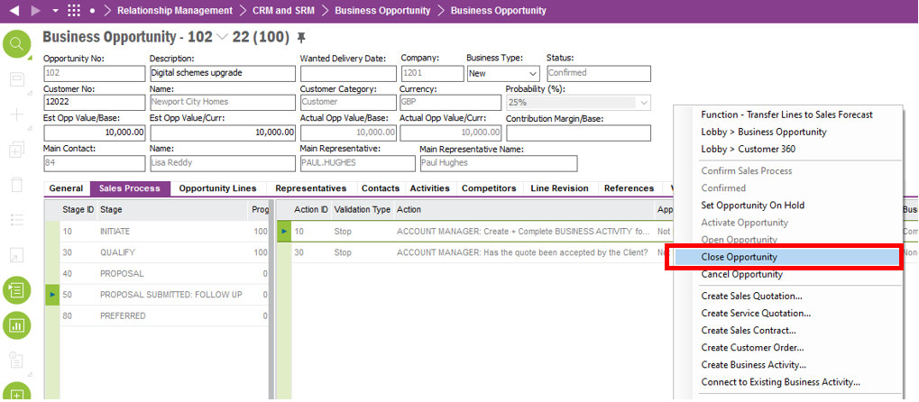

The below screenshot shows the Close Opportunity dialogue box when Closing a Business Opportunity.

If closing the opportunity does not convert the Business Opportunity into an object in IFS such as a Sales Quotations, Service Quotations, Sales Contracts or Customer Orders. Then the opportunity should not be able to be closed with Closed Status “Won”.

The business opportunity must be linked to an object such as Sales Quotations, Service Quotations, Sales Contracts or Customer Orders in IFS before it can be closed with status Won. Or closing the Opportunity converts the Busines Opportunity into Sales Quotations, Service Quotations, Sales Contracts, Customer Orders objects.

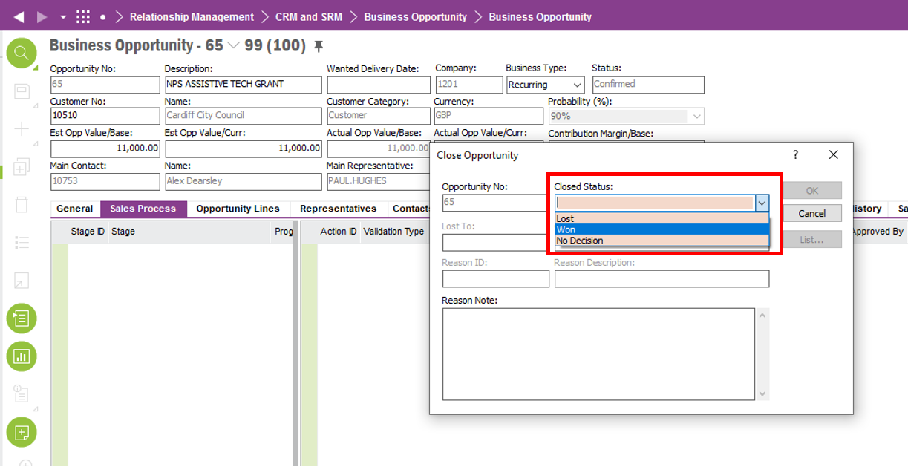

**Technical.**

Field Definitions.

<New Field/CLU Definition>

|  |  |  |  |  |  |  |
| --- | --- | --- | --- | --- | --- | --- |
| New DB Object Name | DB Object Item/Field Names | Item Description | Item Data Type | Item Syntax | Calculation Spec, if Derived | LOVs/Enums/Is Mandatory? |
|  |  |  |  |  |  |  |
|  |  |  |  |  |  |  |
|  |  |  |  |  |  |  |
|  |  |  |  |  |  |  |
|  |  |  |  |  |  |  |
|  |  |  |  |  |  |  |
|  |  |  |  |  |  |  |
|  |  |  |  |  |  |  |
|  |  |  |  |  |  |  |
|  |  |  |  |  |  |  |
|  |  |  |  |  |  |  |
|  |  |  |  |  |  |  |

Security

<Define security controls> (Who needs access to this and will it be restricted from any other users etc)

Companies

Applies to the following companies. All.

|  |  |
| --- | --- |
| **Company** | **Required (Y/N)** |
| 1201 | Y |
| TBC |  |
|  |  |

Data Migration

<Describe any data migration impacts this development may have – i.e additional data to be migrated>

Test Steps

<Steps that needs to be taken to test this change. Please provide expected results> Updated post solution.

|  |  |  |
| --- | --- | --- |
| **No** | **Script\Test Steps** | **Expected Result** |
|  | Attempt to close an opportunity as with closed status WON, if by closing opportunity does not convert the opportunity in the follow: Sales Quotations, Service Quotations, Sales Contracts or Customer orders in IFS. | The system will error.  Or the “Closed Status: Won” will not be selectable. |
|  |  |  |

Technical Implementation

Following Custom Objects are used in this implementation;  
  
Custom Event: BUSI_OPPO_STATUS_VALIDATE  
  
